Evaluators Handout

Team 10126

Mahmoud Gouda
Momen Mohamed
Omar Yasser
Ahmed Mohamed
Ahmed Hany

- Force Analysis
1.1 Force Acting on the Brace Members
The 26.9 cm diagonal is Member 1, and the 30.6 cm diagonal is Member 2.
The axial force acting on the diagonals =
$$F=\frac{P}{2\sin\left(θ\right)}$$
Where
$P$ = 2 kg × 9.8 N = 19.6 N
$θ$ = 45° For Member 1, and 38.3° For Member 2
by substituting
For Member 1: $F=\frac{19.6N}{2\sin\left(45°\right)}=13.86N$
For Member 2: $F=\frac{19.6N}{2\sin\left(38.3°\right)}=15.87N$
1.2 The Stress on The Brace Members
The axial Stress acting on the diagonals =
$$σ=\frac{F}{A}$$
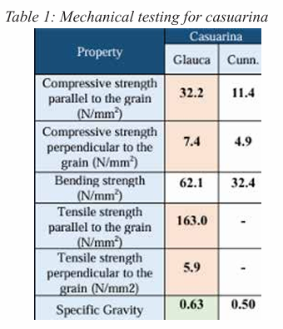
Where
$F$ = $13.86N$ For Member 1, And $F$ = $15.87N$ For Member 2.
$A$ (cross-sectional area) = 40 mm × 40 mm = 1600 mm²
by substituting
For Member 1: $σ=\frac{13.86 N}{1600 mm2}=0.00866 N/mm2$
For Member 2: $σ=\frac{15.87 N}{1600 mm2}=0.00986 N/mm2$
The applied stress on the brace members is much lower than the compressive and tensile strength of the structural material (casuarina wood), as shown in Table 1.

- Thermal conductivity properties
2.1 Force Acting on the Brace Members
The 26.9 cm diagonal is Member 1, and the 30.6 cm diagonal is Member 2.
The axial force acting on the diagonals =
$$F=\frac{P}{2\sin\left(θ\right)}$$
Where
$P$ = 2 kg × 9.8 N = 19.6 N
$θ$ = 45° For Member 1, and 38.3° For Member 2
by substituting
For Member 1: $F=\frac{19.6N}{2\sin\left(45°\right)}=13.86N$
For Member 2: $F=\frac{19.6N}{2\sin\left(38.3°\right)}=15.87N$
1.2 The Stress on The Brace Members
The axial Stress acting on the diagonals =
$$σ=\frac{F}{A}$$

Where
$F$ = $13.86N$ For Member 1, And $F$ = $15.87N$ For Member 2.
$A$ (cross-sectional area) = 40 mm × 40 mm = 1600 mm²
by substituting
For Member 1: $σ=\frac{13.86 N}{1600 mm2}=0.00866 N/mm2$
For Member 2: $σ=\frac{15.87 N}{1600 mm2}=0.00986 N/mm2$
The applied stress on the brace members is much lower than the compressive and tensile strength of the structural material (casuarina wood), as shown in Table 1.

